Registration of NEW CLIENTS outside CULS at the web interface

(via the accommodation programme ISKAM4)

(who have never before resided at CULS dormitories, but want to)

We have introduced a new service that allows brand new clients to register for accommodation using the ISKAM4 accommodation programme.
Who has this service been created for?
- only for those who are applying for accommodation in CULS dormitories for the first time and have never had accommodation at CULS before.

Who has´nt this service been created for?

- for newly accepted students, current students or students on study stays from CULS – these students’ data will be retrieved from CULS data sources (their application for study, University information system - UIS)

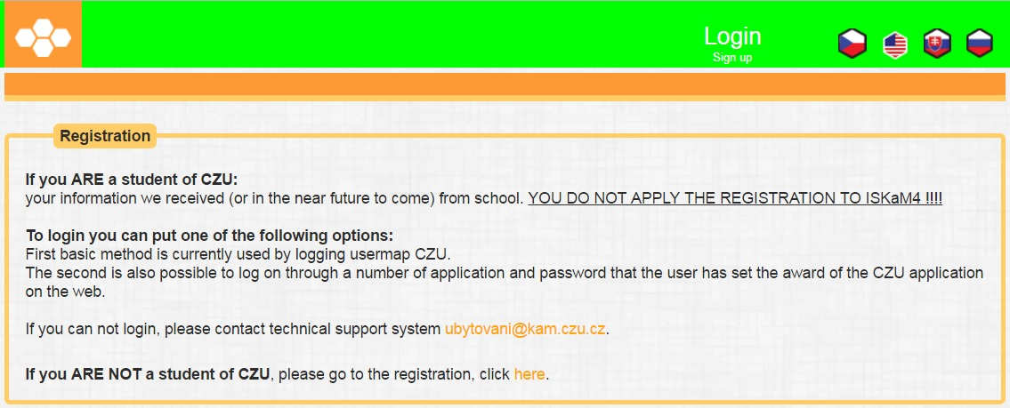

CONDITIONS OF REGISTRATION:

I confirm that all information stated in the registration form is true and am aware of all and any consequences for stating false information. The accommodated person agrees that CTU SFA can process his/her
personal data pursuant to Act No.101/2000 Coll., on the protection of personal data and on amendments to certain acts for a
period of 10 years after the termination of accommodation, including his/her birth registration number. By submitting this registration form, I confirm my
intent to register.

In addition, I declare that I am NOT a student of CULS (not a newly accepted student, a current student or a student on study stay from CULS).

Proceed to the following link: https://iskam.czu.cz/Registrace/RegistraceCZU

The following window will open – once it does, fill in the required data marked with an asterisk (*). Remember to check the section saying that you CONFIRM the authenticity of the data and agree to the terms specified in the Accommodation Contract.

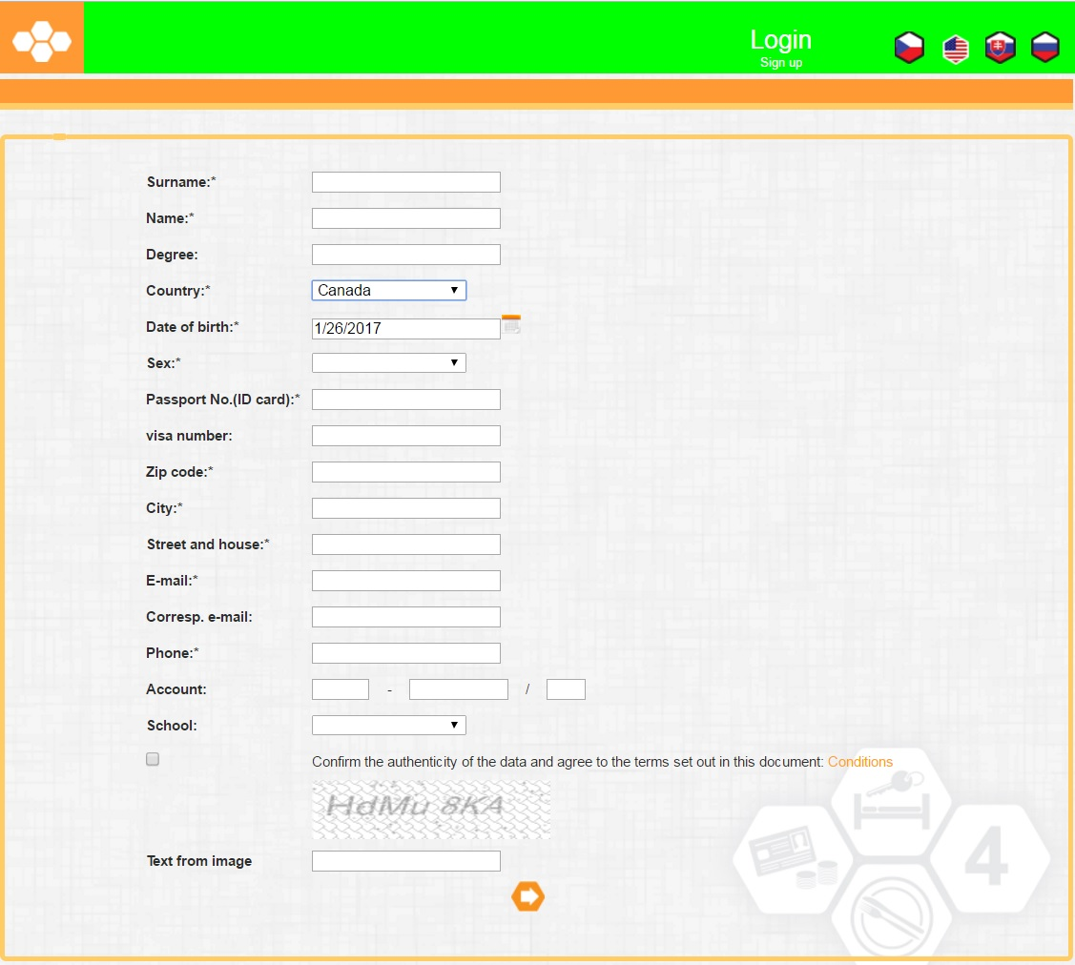

After clicking the orange symbol with an arrow (pointing to the right), the following window will open:
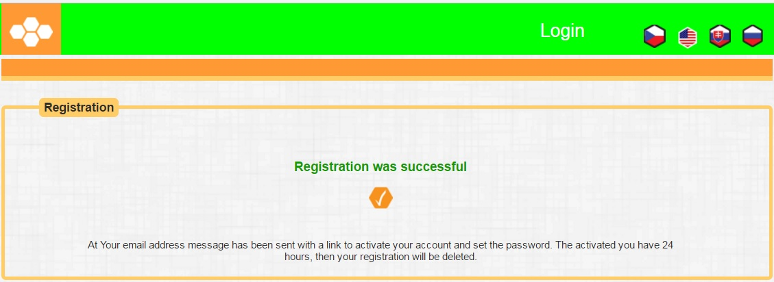

At the same time, an informational e-mail will be sent to the e-mail address you entered when registering.

In order to create a password to access the web interface, use the information you received by e-mail:
An image of the informational e-mail can be seen below.
-------------------------------------------------------------------------------------------------------------
http://web.iskam.czu.cz/Prihlaseni/AuthNewPass?ISKAM=474880BB17F9279EF345429D14BE5F138504F5977AA9445EA1C0C20F3E30CE30D7EADC304A27F7921D331F5B78418AF55555D770A80E6D4493357F9A41FEDD1

Message content:
Use the following link to activate your access to the ISKAM accommodation system:

You will be prompted to set your password for future access. Please note that this link may be used just once and is valid for only 24 hours.

Contact the accommodation department in case of any difficulties.
===========================================================================
After successful registration and successfully signing in (sign in using the registered e-mail address with the login name and the password you created), you can APPLY FOR DORMITORY ACCOMMODATION
via the web interface**.

===========================================================================
**Note: You can apply for dormitory accommodation only during the time that CULS
is processing applications for dormitory accommodation. https://kam.v2.czu.cz/en/r-10442-documents-and-forms/Prices-and-Contract/Provisions for Accommodation of Students in Daily Studies_AY_2017_2018

